SQL Injection
# Source: AI Source: Provided by: [Data Path: Persons Table -> ID Column: 1, Name_En Column: Motasem Essam] -> From: [ChatGPT] on [1/18/2026]
SQL Injection (SQLi) is a type of code injection attack that allows an attacker to interfere with the queries your web application makes to its database.
If the application doesn’t properly validate or sanitize user input, an attacker can inject malicious SQL code to:
- View unauthorized data
- Bypass authentication
- Modify or delete data
- Execute administrative operations on the database

🧪 Example of a Vulnerable Query (Insecure Code)
# Source: AI Source: Provided by: [Data Path: Persons Table -> ID Column: 1, Name_En Column: Motasem Essam] -> From: [ChatGPT] on [1/18/2026]
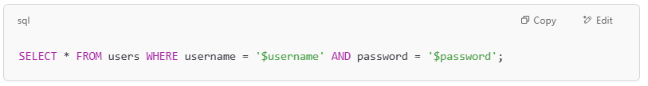
SELECT * FROM users WHERE username = '$username' AND password = '$password';

If the user inputs this for username:
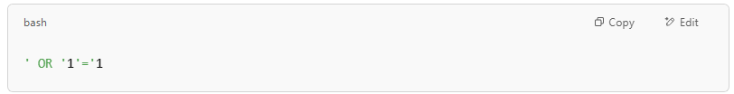
' OR '1'='1

The query becomes:
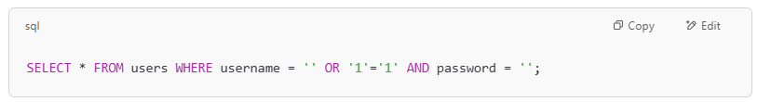
SELECT * FROM users WHERE username = '' OR '1'='1' AND password = '';

✅ 1 = 1 is always true, so the attacker bypasses login without knowing a password.

🛠️ What Attackers Can Do with SQL Injection
# Source: AI Source: Provided by: [Data Path: Persons Table -> ID Column: 1, Name_En Column: Motasem Essam] -> From: [ChatGPT] on [1/18/2026]

Goal | Example Payload | Result
Bypass login | ' OR '1'='1 | Logs in without valid credentials
Extract data | ' UNION SELECT credit_card, NULL-- | Dumps credit card data
Delete data | '; DELETE FROM users-- | Deletes all user records
Add new user | '; INSERT INTO users (...) VALUES (...)-- | Adds an admin account

🔒 How to Prevent SQL Injection
# Source: AI Source: Provided by: [Data Path: Persons Table -> ID Column: 1, Name_En Column: Motasem Essam] -> From: [ChatGPT] on [1/18/2026]

Technique | Description
✅ Use Prepared Statements | Parameterized queries ensure user input is treated as data, not code
✅ Use ORM frameworks | Object-relational mappers like Sequelize, Django ORM, or SQLAlchemy are safer
✅ Escape Inputs Carefully | If using dynamic SQL, escape special characters (but this is error-prone)
✅ Whitelist Inputs | Allow only expected input formats (e.g., numbers, email formats)
✅ Limit DB Permissions | Use DB users with minimal rights (e.g., no DROP TABLE permission)
✅ Security Testing | Run automated scanners or manual penetration tests

Vulnerability | SQL Injection (SQLi)
Affects | Databases
Caused by | Unsanitized user input in SQL queries
Impact | Data theft, data loss, authentication bypass
Prevention | Prepared statements, input validation, least privilege

